PROJECT TITILE
Deploy Three-Tier DevSecOps Kubernetes Project on AWS EKS with ArgoCD, Prometheus, Grafana, Jenkins

1
Listen
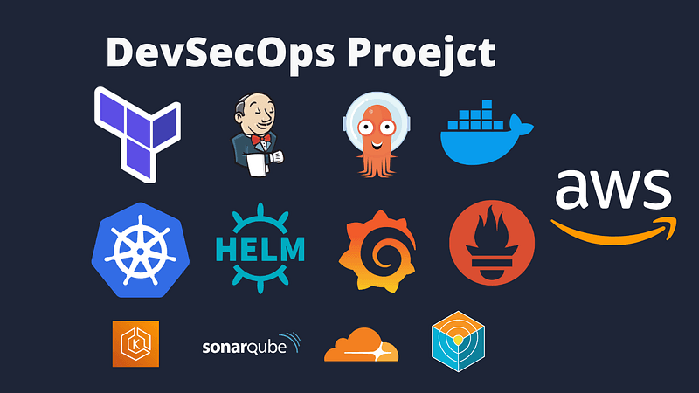
- Pipeline Automation: Build, scan, and deploy Docker images using Jenkins, Trivy, and SonarQube.
- Cluster Monitoring: Install Prometheus and Grafana to monitor application health with visual dashboards.
- GitOps with ArgoCD: Achieve seamless application deployment and updates via Git repositories.
- End-to-End DevSecOps Workflow: Incorporate security scans, monitoring, and scalable infrastructure for a production-ready deployment.
.
Steps:
- IAM User Setup: Create an IAM user with the necessary permissions for EKS, S3, DynamoDB, ECR, and EC2.
- Terraform & AWS CLI Installation: Install Terraform and AWS CLI on your local machine and configure AWS CLI with IAM credentials.
- S3 Bucket and DynamoDB Table: Set up an S3 bucket for Terraform state files and a DynamoDB table for state locking.
- Infrastructure as Code (IaC): Use Terraform and AWS CLI to set up the Jenkins server (EC2 instance) on AWS.
- Jenkins Server Configuration: With shell script & terraform install Jenkins, Docker, Docker Compose, Terraform, Kubectl, AWS CLI, Trivy, and SonarQube.
- Installing Plugins on Jenkins: Install Jenkins plugins, including AWS Credentials, AWS Steps, Docker plugins, Eclipse Temurin installer, NodeJS, OWASP Dependency-Check, and SonarQube Scanner.
- SonarQube Setup: Integrate SonarQube for code quality analysis within the Jenkins pipeline.
- Amazon ECR Repositories: Create Amazon ECR repositories for frontend and backend images and configure Jenkins to push Docker images to ECR.
- EKS Cluster Deployment: Deploy the EKS cluster with Terraform, including VPC, subnets, security groups, and IAM roles.
- Prometheus and Grafana Installation and Configuration: Use Helm to install Prometheus and Grafana on the EKS cluster and set up monitoring dashboards.
- Jenkins Pipelines (Frontend & Backend): Set up Jenkins pipelines for frontend and backend applications with stages for building, testing, scanning, and deploying.
- ArgoCD Installation & Application Deployment: Install ArgoCD on the EKS cluster and configure it to deploy applications automatically from a Git repository.
- DNS Configuration: Configure DNS to point to the EKS load balancer or Ingress endpoint, and to make applications available on a subdomain using Cloudflare.
- Data Persistence: Implement persistent volume and persistent volume claims for database pods to ensure data persistence.
- Conclusion: Test the end-to-end deployment, verify integrations, and ensure that monitoring, alerting, and scaling settings are in place for production readiness.
1. IAM User Setup
Create an IAM user with the necessary permissions for EKS, S3, DynamoDB, ECR, and EC2.
On AWS Console, search I am, and click Users.
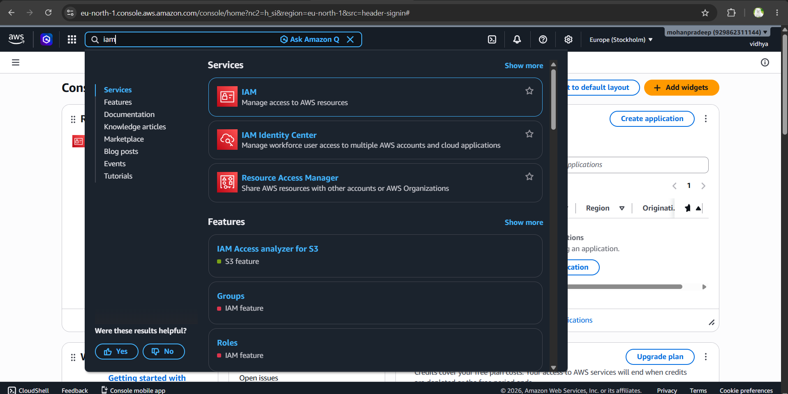
aws console
Next, click Create User
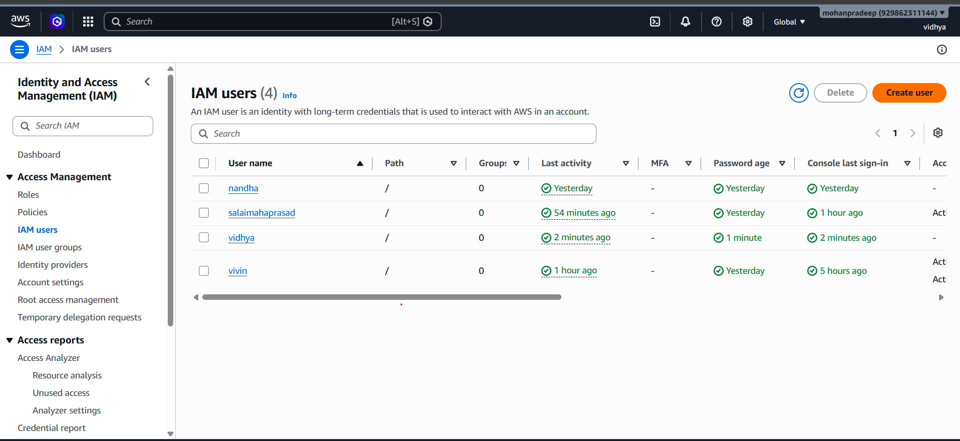
click create user
Give a username to your iam User.

IAM user name
Attach administrative access for testing; for your company project, assign limited policies, and click Create user.
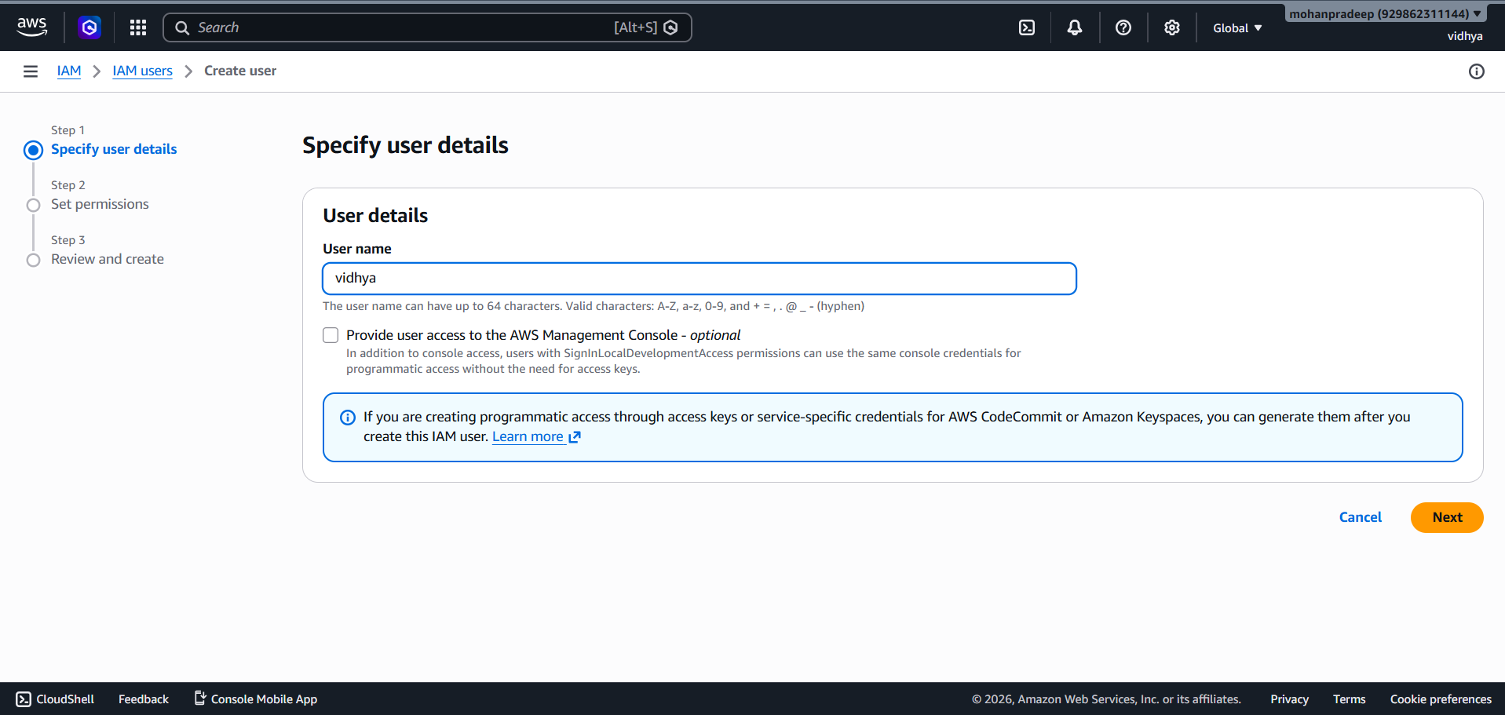

Now you can create an access key
Click Security Credentials, and click on create access key.
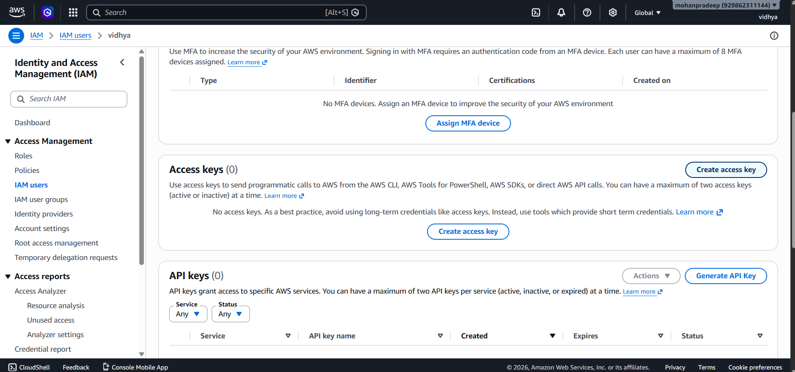
access key
Click Command Line Interface (CLI)
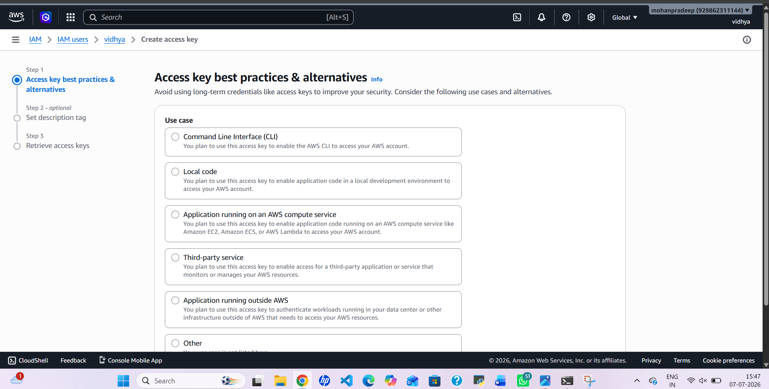

Download the file for later use of the secret key and access key.
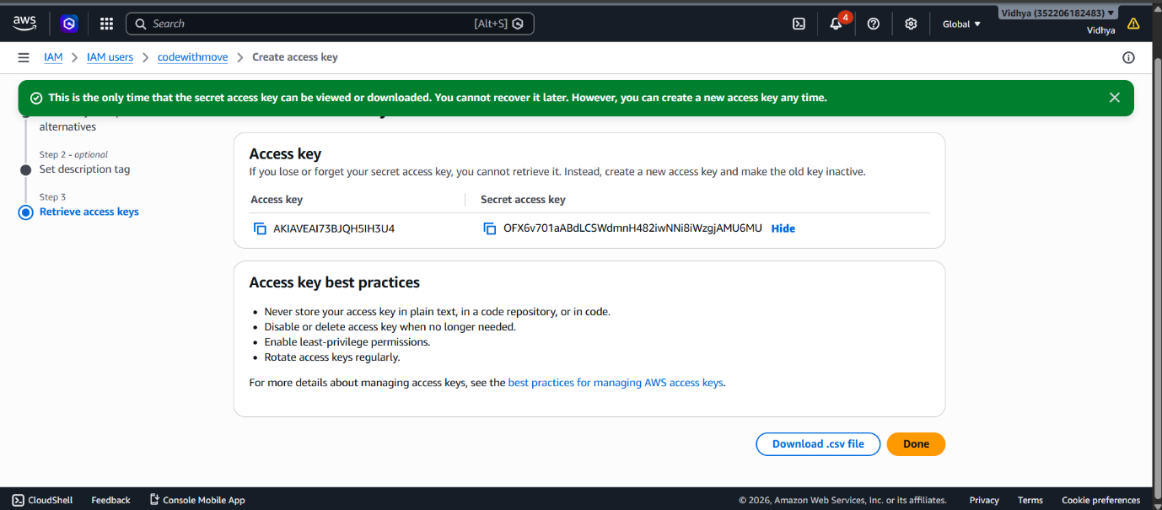

We have done now with IAM user creation.
2. Terraform & AWS CLI Installation
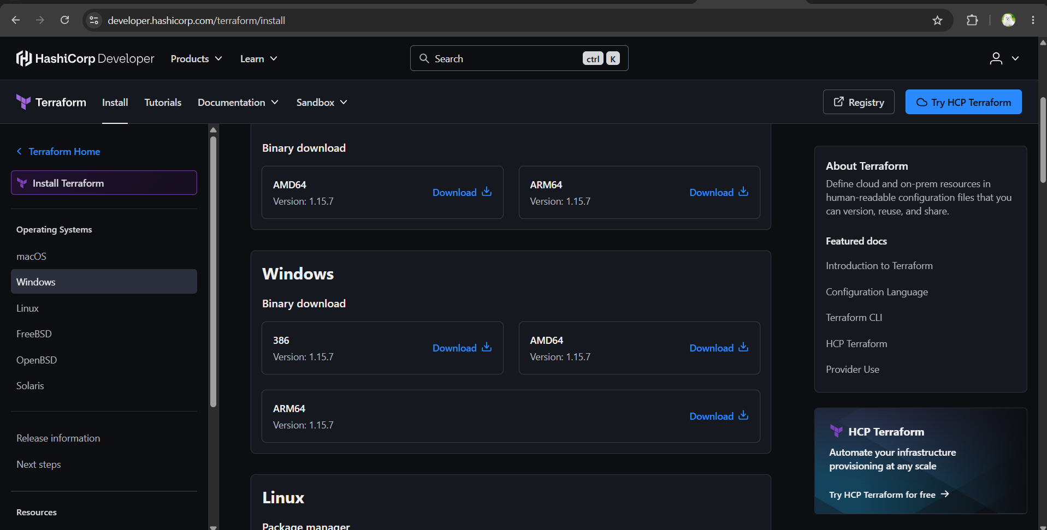
To install Terraform, You can visit Terraform official website.
To install AWS CLI, You can Visit AWS installtion page.
After installation, you can verify installation with these two commands
terraform --version
aws --version
Then configure aws CLI using the given blow commands, Use Access and secret key from the CSV file you download in the IAM User step.
aws configure
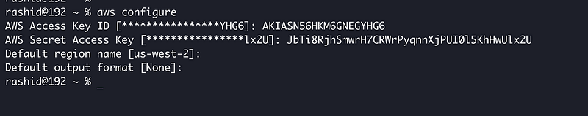
3. S3 Bucket and DynamoDB Table
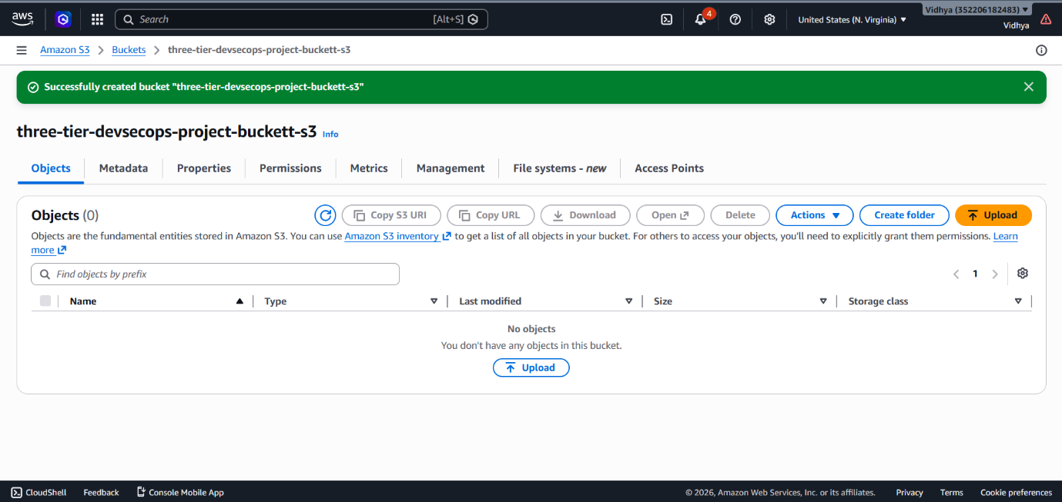

As S3 Bucket and Dynamo DB are required for Terraform’s backend state, you can create them by watching my video.
S3 bucket can be any, give any unique name to it.
lock-files name will be DynamoDB table, and the partition key will be LockID.
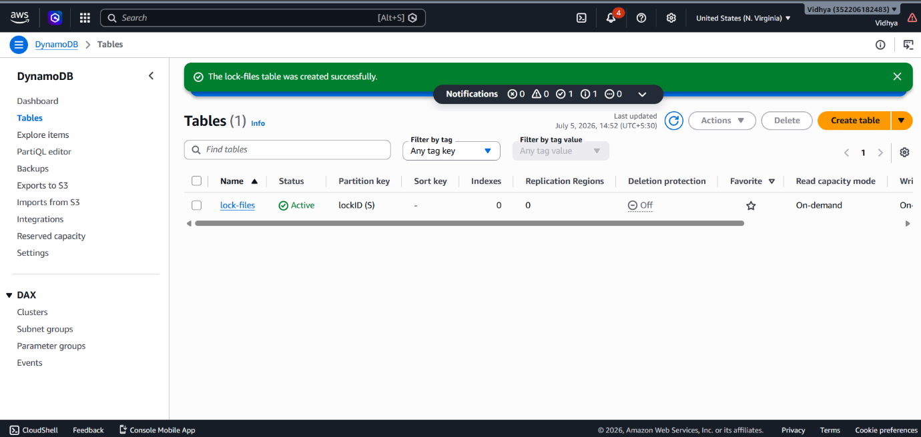

4. Jenkins EC2 Server Setup with Terraform
Clone the git repo.
git clone https://github.com/codewithmuh/three-tier-devsecops-project.git
Go to the folder jenkins-server-terraform in the terminal.
Just make sure to make changes in backend.tf file. Update the name of the s3 bucket and dynamo db name.
Next, we have to run the command to create .pem file for our Jenkins instance. will be used to ssh the server.
aws ec2 create-key-pair --key-name devsecops-project --query "KeyMaterial" --output text > devsecops-project.pem
Now run this command to create a Jenkins server.
terraform init
terraform validate
terraform apply
Now ssh to your server :
Make sure you run these commands from the folder where your pem file exist.
chmod 400 "devsecops-project.pem"
ssh -i "devsecops-project.pem" ubuntu@35.92.246.29
configure aws on the Jenkins server(EC2 Instance). As you did for your local machine.
aws configure
5. Installing Plugins on Jenkins
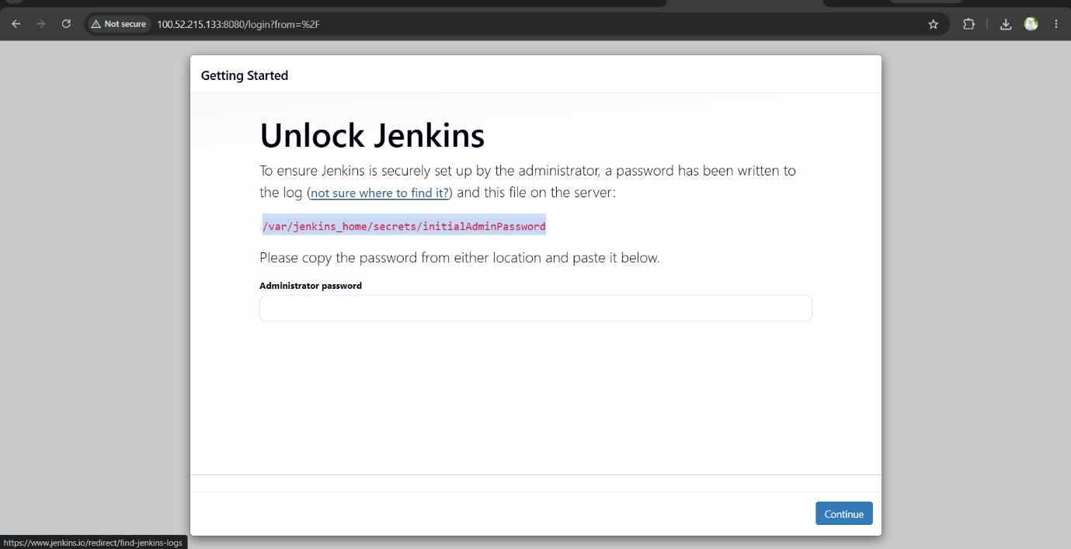

Open the EC2-IP:8080 in the browser.
You can get the password of Jenkins
sudo cat /var/lib/jenkins/secrets/initialAdminPassword
Install recommended plugins.
After creating Jenkins accounts, go to manage Jenkins -> plugins -> available plugins
We have to install all these mentioned plugins.
AWS Credentials
AWS Steps
Docker plugins
Eclipse Temurin installer
NodeJS
OWASP Dependency-Check,
SonarQube Scanner.
6. SonarQube Setup:
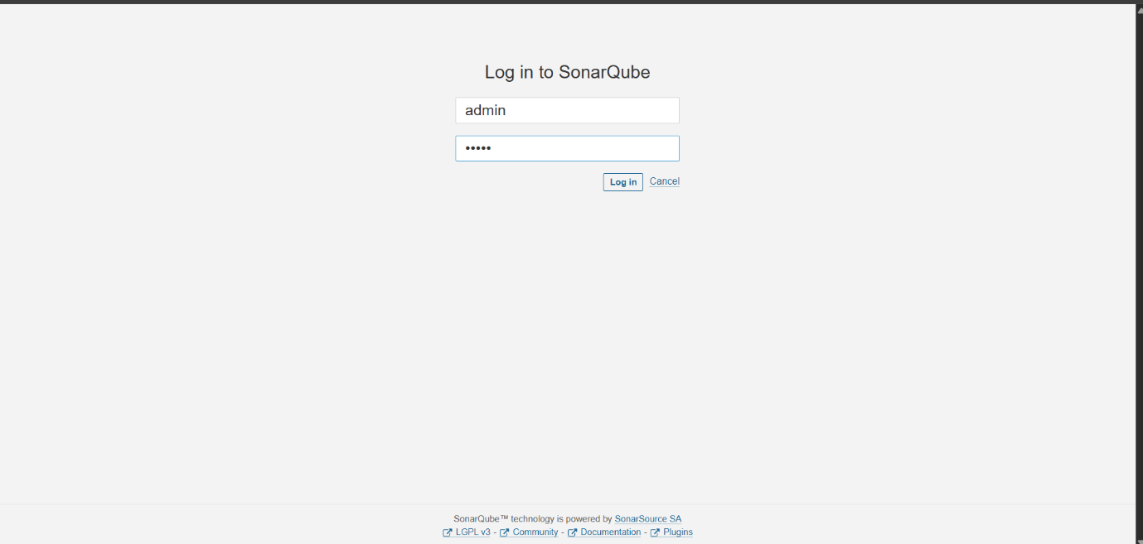

Open Sonarrqube in the browser.
http://<jenkins-server-public-ip>:9090
username and password for sonarqube is admin.
Next, We have to perform 5 Steps on the sonarqube setup.
- Setup of frontend project for code analysis
- Setup of backend project for code analysis
- Replace the keys in jenkins-pipeline folder, you got from the above two steps. (watch video sonarqube setup)
- create a sonar-token, and save it somewhere for later use in Jenkins.
- create a webhook on the sonarqube dashboard. (http://<jenkins-ec2-server-public-ip>:8080/sonarqube-webhook/)
7. Amazon ECR Repositories
Create two repositories, one for the backend and front end.
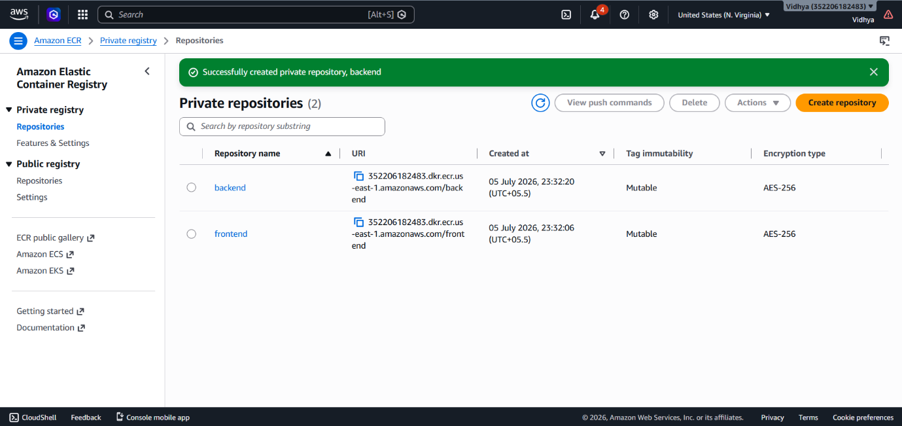

Login to ECR on the Jenkins server, using the ECR push command.
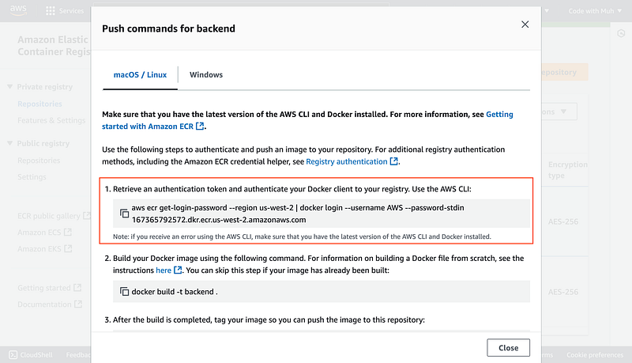
7a. Add Cred. in Jenkins
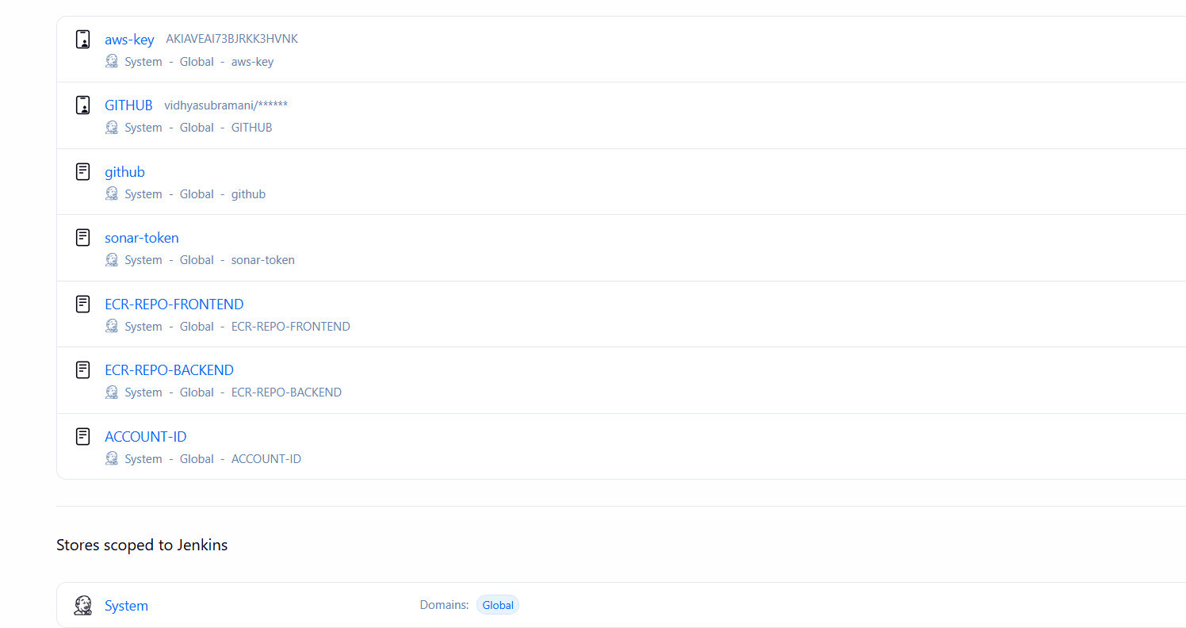
Got to Manage Jenkins -> Credentials.
We have to add here a total of 7 Credentials.
aws-key
GITHUB (username & Password)
github (secret text)
sonar-token

ECR_REPO_FRONTEND
ECR_REPO_BACKEND
ACCOUNT_ID (aws account id)
Now We have to configure the installed plugins. (important)
In Tools, We have to configure JDK, sonar-scanner, nodejs, DP-Check, and docker.
Go to Dashboard -> Manage Jenkins -> System
Search for SonarQube installations
Provide the name as it is, then in the Server URL copy the sonarqube public IP (same as Jenkins) with port 9000 select the sonar token that we have added recently, and click on Apply & Save.
8. EKS Cluster Deployment

We have to create EKS Cluster using the below commands.
eksctl create cluster --name three-tier-k8s-eks-cluster --region us-west-2 --node-type t2.medium --nodes-min 2 --nodes-max 2
Once the cluster is ready, you can validate if the nodes are ready or not.
kubectl get nodes
Now, we will configure the Load Balancer on our EKS because our application will have an ingress controller.
Download the policy for the LoadBalancer prerequisite.
curl -O https://raw.githubusercontent.com/kubernetes-sigs/aws-load-balancer-controller/v2.5.4/docs/install/iam_policy.json
Create the IAM policy using the below command
aws iam create-policy --policy-name AWSLoadBalancerControllerIAMPolicy --policy-document file://iam_policy.json
Create OIDC Provider
eksctl utils associate-iam-oidc-provider --region=us-west-2 --cluster=three-tier-k8s-eks-cluster --approve
Create a Service Account by using below command and replace your account ID with your one
eksctl create iamserviceaccount --cluster=three-tier-k8s-eks-cluster --namespace=kube-system --name=aws-load-balancer-controller --role-name AmazonEKSLoadBalancerControllerRole --attach-policy-arn=arn:aws:iam::<your-account-id>:policy/AWSLoadBalancerControllerIAMPolicy --approve --region=us-west-2
Run the below command to deploy the AWS Load Balancer Controller
helm repo add eks https://aws.github.io/eks-charts
helm repo update eks
helm install aws-load-balancer-controller eks/aws-load-balancer-controller -n kube-system --set clusterName=three-tier-k8s-eks-cluster --set serviceAccount.create=false --set serviceAccount.name=aws-load-balancer-controller
After 2–3 minutes, run the command below to check whether your pods are running or not.
kubectl get deployment -n kube-system aws-load-balancer-controller
9. Prometheus and Grafana Installation and Configuration
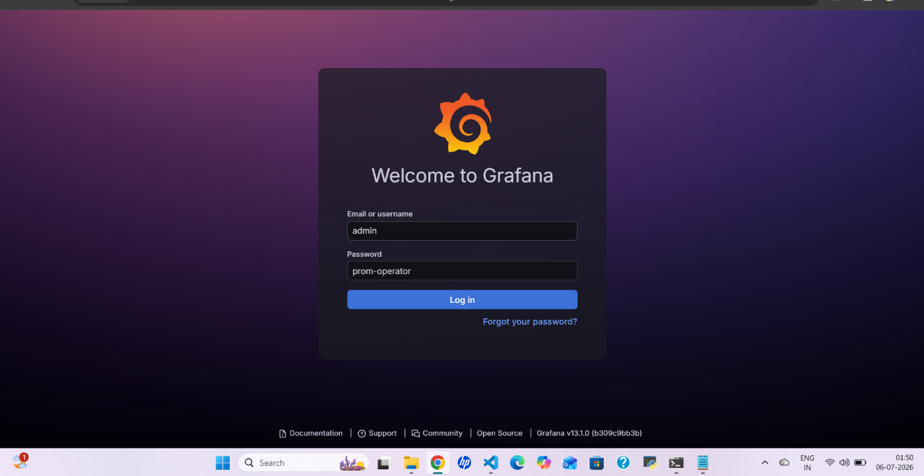

What is Grafana?
Grafana is an open-source platform for visualization and analytics. It allows you to query, visualize, alert on, and explore metrics from various data sources.
Steps to Install and Configure Prometheus and Grafana on Kubernetes
Step 1: Add Helm Repositories
- Add Helm Stable Chart Repository
helm repo add stable https://charts.helm.sh/stable
2. Add Prometheus Community Helm Repository
helm repo add prometheus-community https://prometheus-community.github.io/helm-charts
Step 2: Create a Namespace for monitoring
kubectl create namespace monitoring
Step 3: Install Prometheus with Grafana using Helm
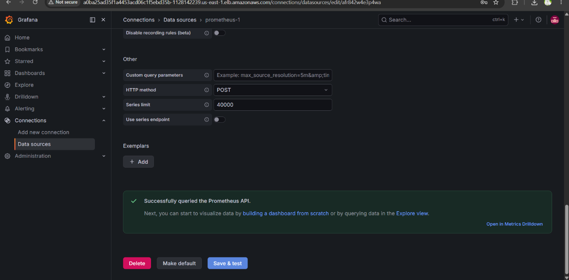

Install the kube-prometheus-stack chart, which includes both Prometheus and Grafana:
helm install stable prometheus-community/kube-prometheus-stack -n monitoring
This command deploys Prometheus and Grafana as part of the kube-prometheus-stack in the prometheus namespace on your EC2 instance.
Step 4: Verify Prometheus Installation
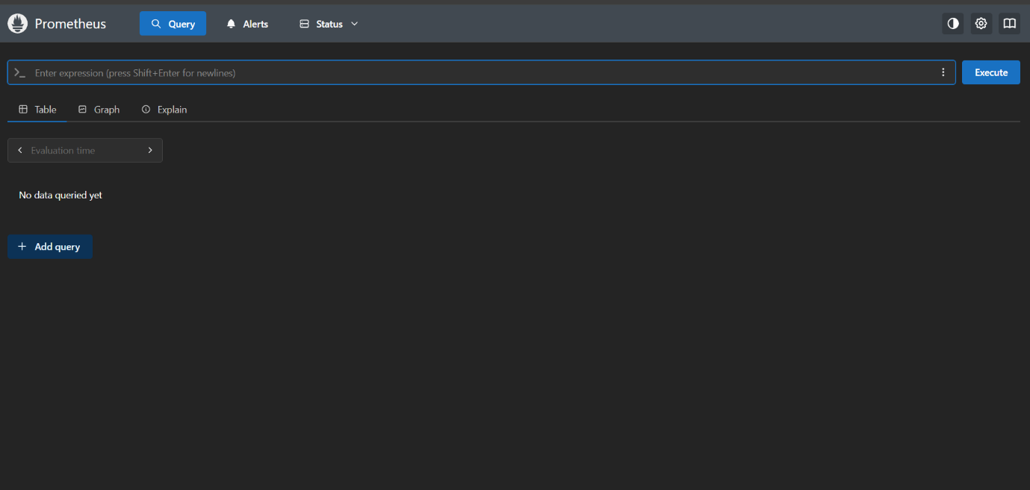
Check the Prometheus pods:
kubectl get pods -n monitoring
Check the Prometheus services:
kubectl get svc -n monitoring
Since Grafana is deployed along with Prometheus, there is no need for separate Grafana installation.
Step 5: Expose Prometheus and Grafana to External Access
There are two ways to expose these services:
- NodePort
- LoadBalancer
Exposing Prometheus via LoadBalancer:
kubectl edit svc stable-kube-prometheus-sta-prometheus -n monitoring
Save the file. The service should now have a load balancer with an external IP to access Prometheus.
Exposing Grafana via LoadBalancer:
Similarly, edit the Grafana service configuration to change ClusterIP to LoadBalancer:
kubectl edit svc stable-grafana -n monitoring
Save the changes and use the load balancer IP in your browser to access Grafana.
Step 6: Accessing Grafana
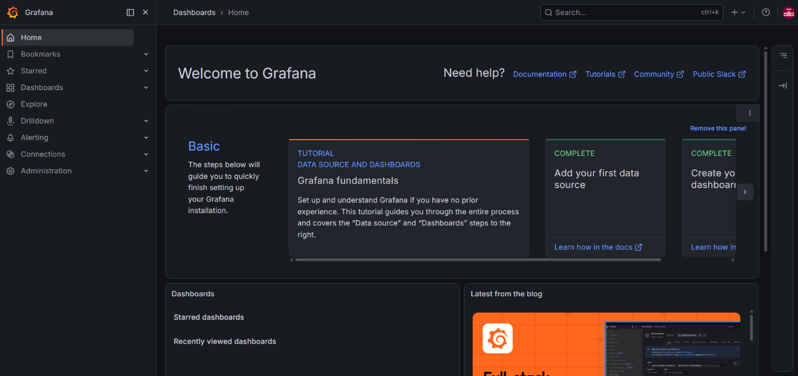

The username will be admin and the password will be prom-operator for your Grafana LogIn.
step of the Grafana dashboard with Prometheus as explained in the video.

10. ArgoCD Installation & Application Deployment
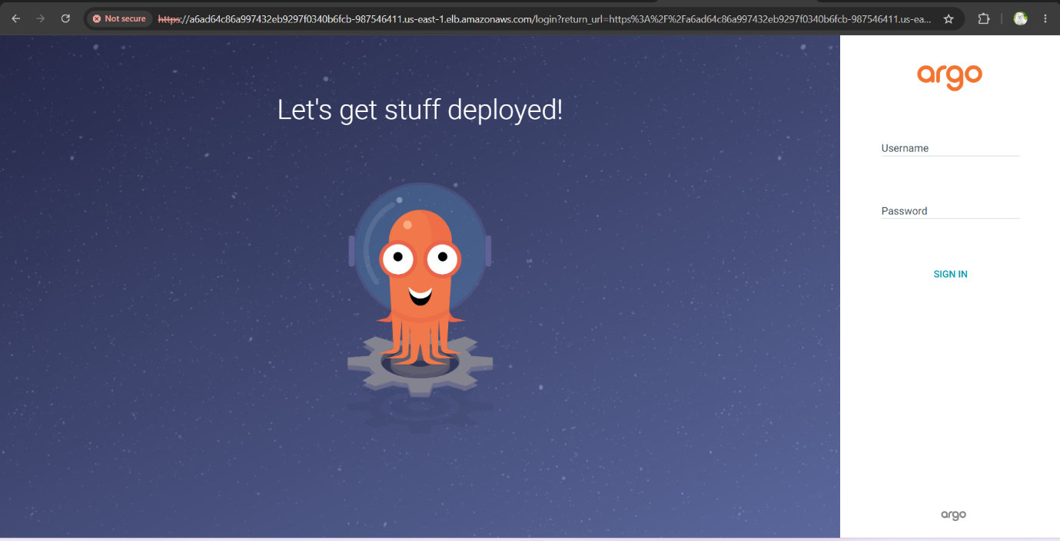

kubectl create namespace three-tier
kubectl create secret generic ecr-registry-secret \
--from-file=.dockerconfigjson=${HOME}/.docker/config.json \
--type=kubernetes.io/dockerconfigjson --namespace three-tier
kubectl get secrets -n three-tier
Now, we will install argoCD.
To do that, create a separate namespace for it and apply the argocd configuration for installation.
kubectl create namespace argocd
kubectl apply -n argocd -f https://raw.githubusercontent.com/argoproj/argo-cd/v2.4.7/manifests/install.yaml
All pods must be running, to validate run the below command
kubectl get pods -n argocd
Now, expose the argoCD server as LoadBalancer using the below command
kubectl patch svc argocd-server -n argocd -p '{"spec": {"type": "LoadBalancer"}}'
You can validate whether the Load Balancer is created o by going to the AWS Console load balancers.
To access the argoCD, copy the LoadBalancer DNS CNAME record and hit on your favorite browser.
Now, we need to get the password for our argoCD server to perform the deployment.
To do that, we have a pre-requisite which is jq. Install it by the command below.
sudo apt install jq -y
export ARGOCD_SERVER=$(kubectl get svc argocd-server -n argocd -o json | jq -r '.status.loadBalancer.ingress[0].hostname') && export ARGO_PWD=$(kubectl -n argocd get secret argocd-initial-admin-secret -o jsonpath="{.data.password}" | base64 -d) && echo "ARGOCD_SERVER: $ARGOCD_SERVER" && echo "ARGO_PWD: $ARGO_PWD"
Next will deploy our Three-Tier Application using ArgoCD
As our repository is private. So, we need to configure the Private Repository in ArgoCD.
Then We have to set up applications.
1. database
2. backend
3. frontend
4. frontend-ingress
5. backend-ingress
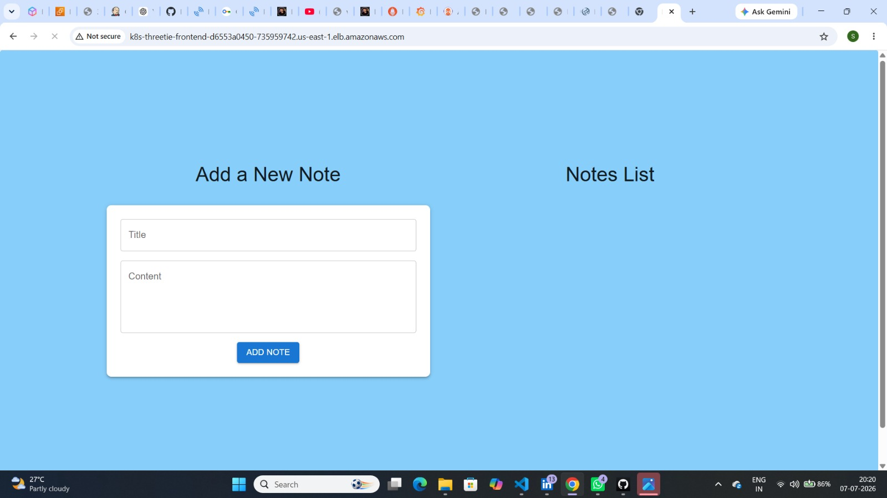
12. Conclusion
We have set up a Persistent Volume and a Persistent Volume Claim. This means that if the pods are deleted, the data will not be lost, as it will be stored on the host machine.
Extra: Clean up Everything. If you did this project for testing. To avoid costs on AWS.
First, you must delete your EKS Cluster, Run this command on your Jenkins server.
eksctl delete cluster --name three-tier-k8s-eks-cluster --region us-west-2 --wait --timeout 30m
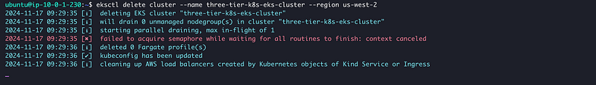
When the cluster is deleted successfully.
Then On the Local machine, destroy the infrastructure in your terminal at folder jenkins-server-terraform
terraform destroy

